**K8s End to End project using AWS EKS**

**AWS Elastic Kubernetes Service**

Amazon Elastic Kubernetes Service (EKS) is a managed Kubernetes service that makes it easy to run Kubernetes on AWS without needing to install and operate your own control plane or nodes manually.

**Key Features of AWS EKS**

1. Fully Managed Kubernetes Control Plane – AWS manages the Kubernetes control plane, including scaling, patching, and security.
2. Integration with AWS Services – Works with IAM, VPC, ELB, CloudWatch, and more for security and monitoring.
3. Multi-Cluster and Multi-Region Support – Deploy workloads across multiple regions for high availability.
4. Fargate Support – Enables serverless Kubernetes by running pods without managing EC2 instances.
5. EKS Managed Node Groups – AWS can manage EC2 instances as worker nodes.
6. Security & Compliance – Integrated with IAM for authentication and supports encryption via AWS KMS.

**EKS Deployment Options**

1. **Self-Managed EC2 Nodes** – Use your own EC2 instances as worker nodes.
2. **EKS Managed Node Groups** – AWS provisions and manages EC2 instances for you.
3. **AWS Fargate** – Serverless option where AWS runs your Kubernetes pods.

**How EKS Works**

1. **Create an EKS Cluster** – AWS provisions a managed control plane.
2. **Launch Worker Nodes** – Use EC2 instances or Fargate to run workloads.
3. **Deploy Kubernetes Applications** – Use kubectl and Helm to deploy applications.
4. **Monitor & Scale** – Use CloudWatch, Prometheus, and auto-scaling features.

**Common Use Cases**

* Running containerized applications at scale
* CI/CD pipelines with Kubernetes
* Multi-cloud and hybrid deployments
* Machine learning workloads with GPU support

**Project Architecture: -**

Deployment of 2048 app in EKS cluster



**Project Steps: -**

Prerequisites (in local system to interact with EKS cluster): -

Install Kubectl

Install eksctl

Install AWS CLI

Log in to AWS management console

1. **Creation of EKS Cluster using eksctl.**

**Command : -**

**eksctl create cluster --name demo-cluster --region us-east-1 –fargate**

above command creates a EKS cluster in us-east-1 region using fargate as data node.

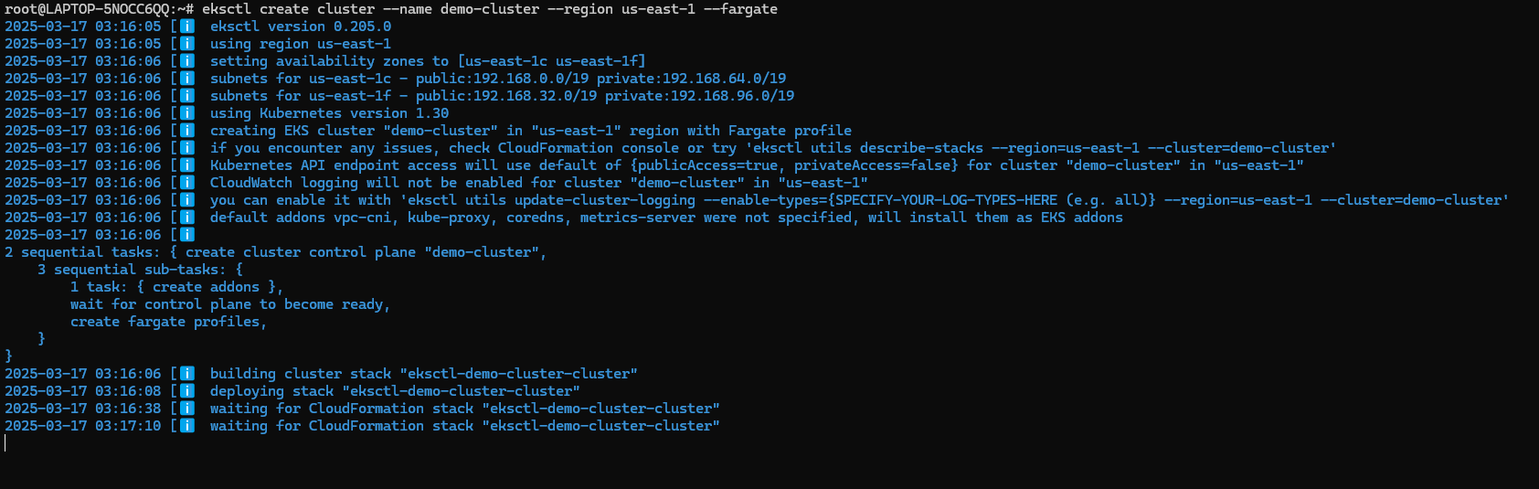

Cluster is creating it will take around 15 mins to create cluster.

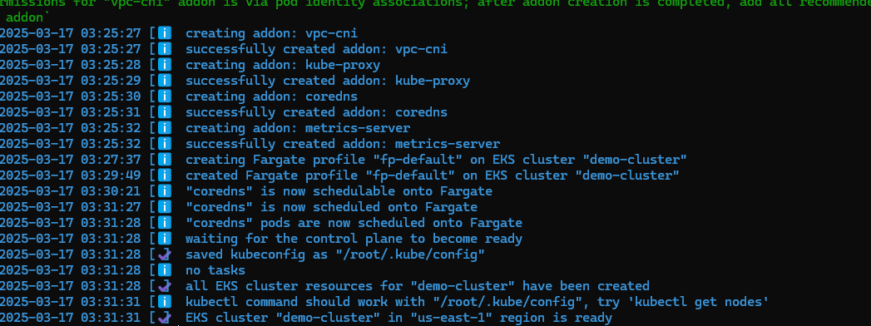

Cluster Created

